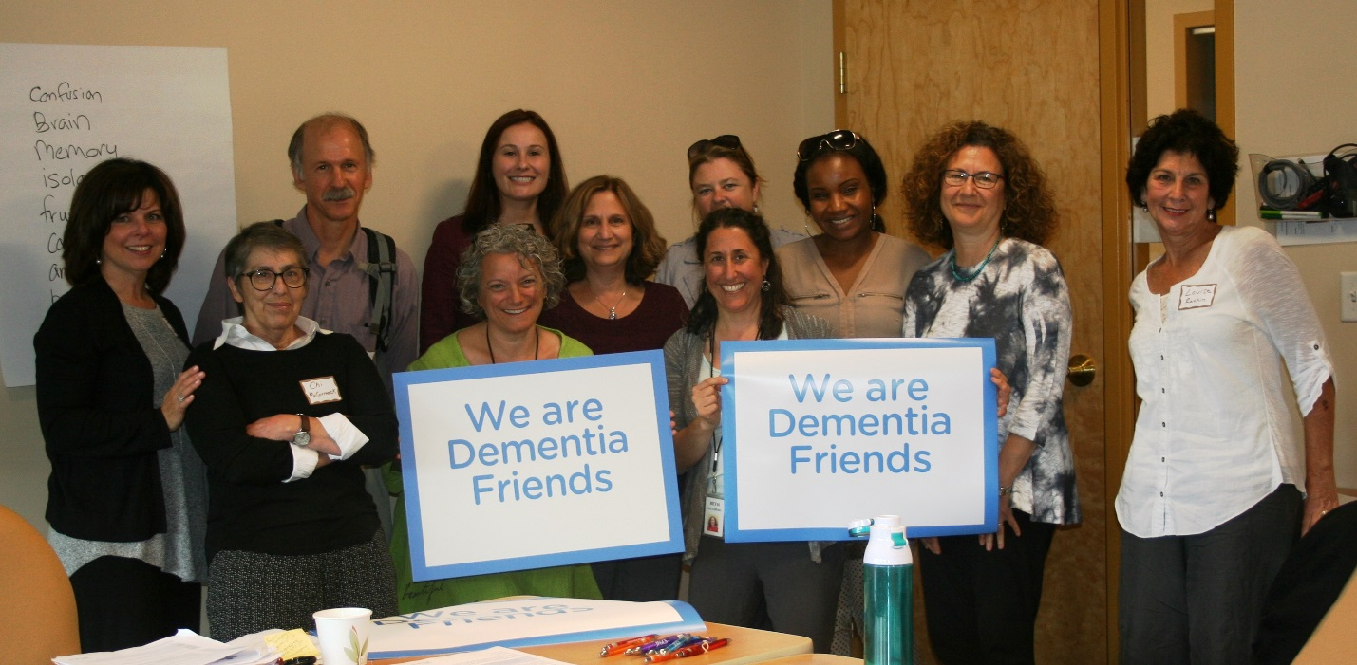
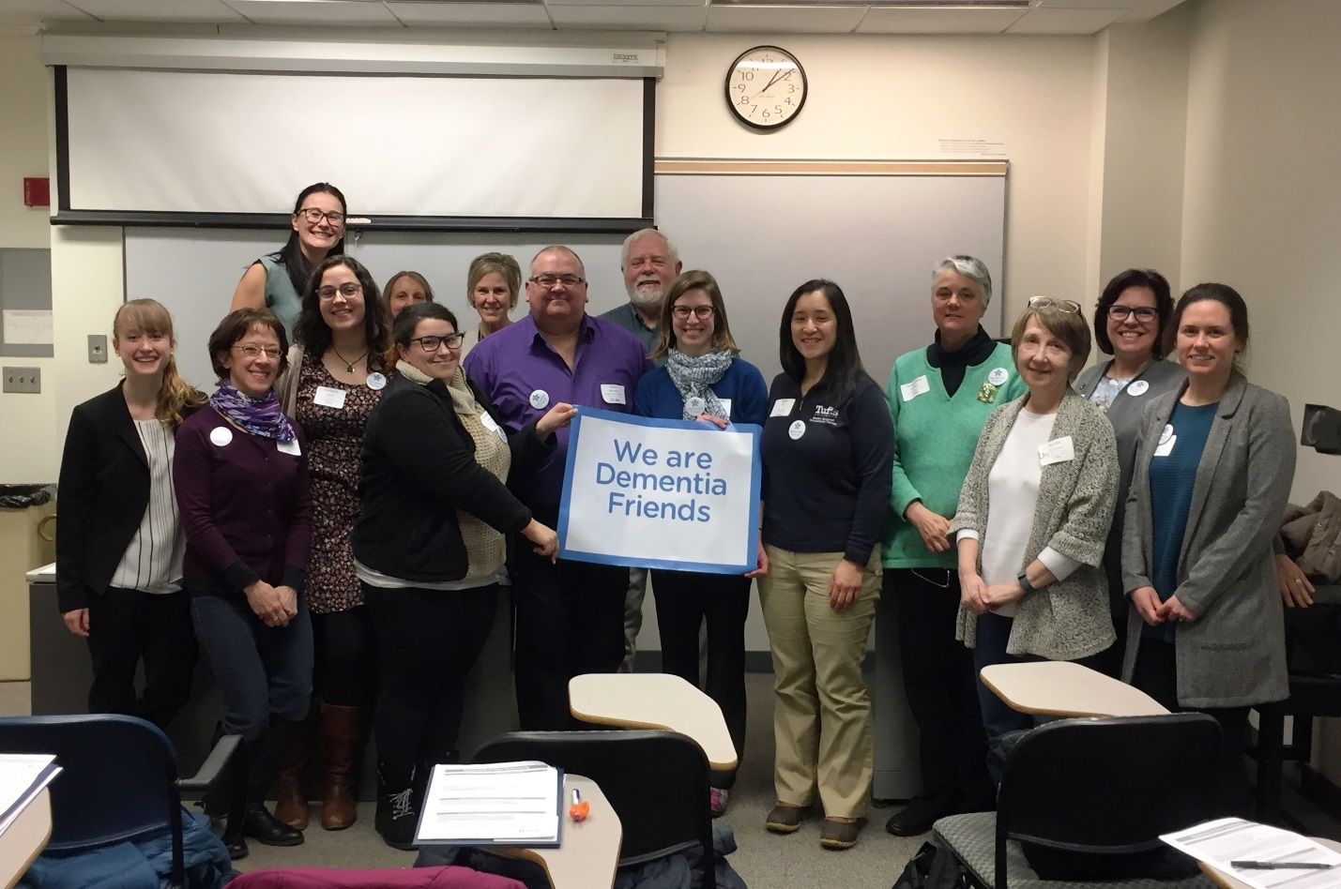
Very first Champion training in MA, JF&CS, led by Beth Soltzberg
OT conference, led by Daria Rabkin and Mike Belleville

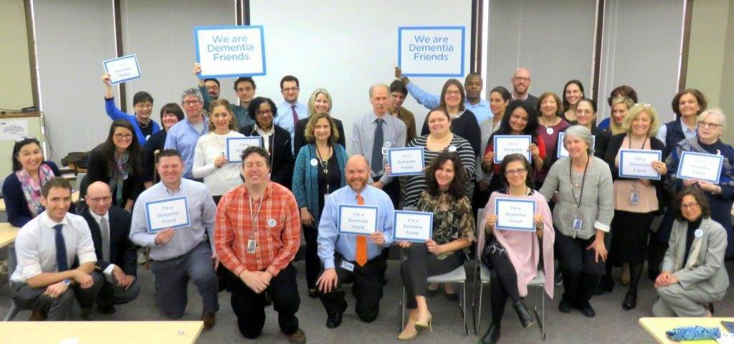
Massachusetts Executive Office of Elder Affairs, led by Mitch Evich and Pam MacLeod

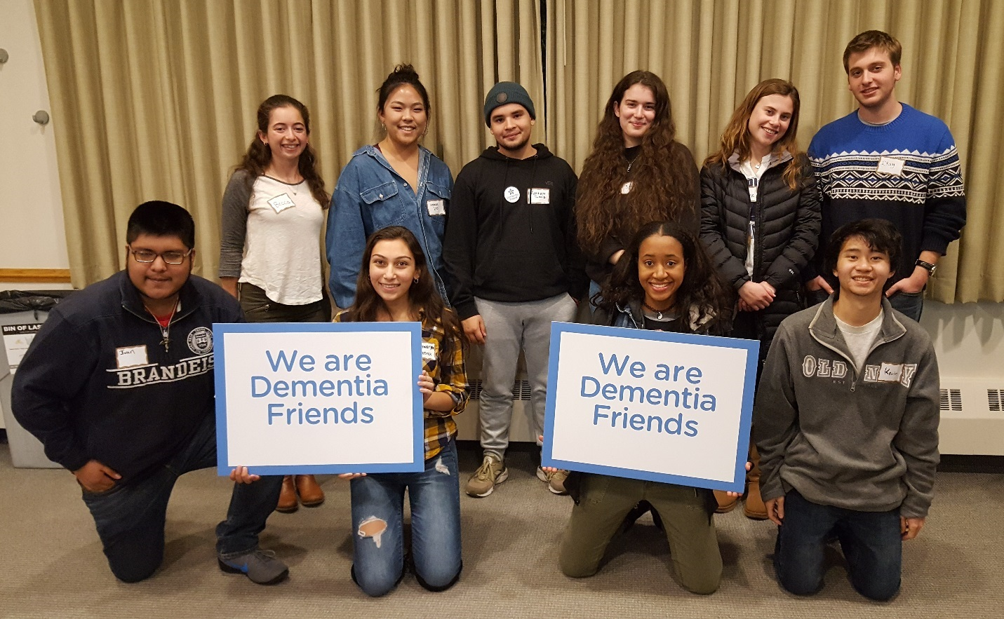
Brandeis, Students to End Alzheimer’s Disease (SEAD), led by Beth Soltzberg

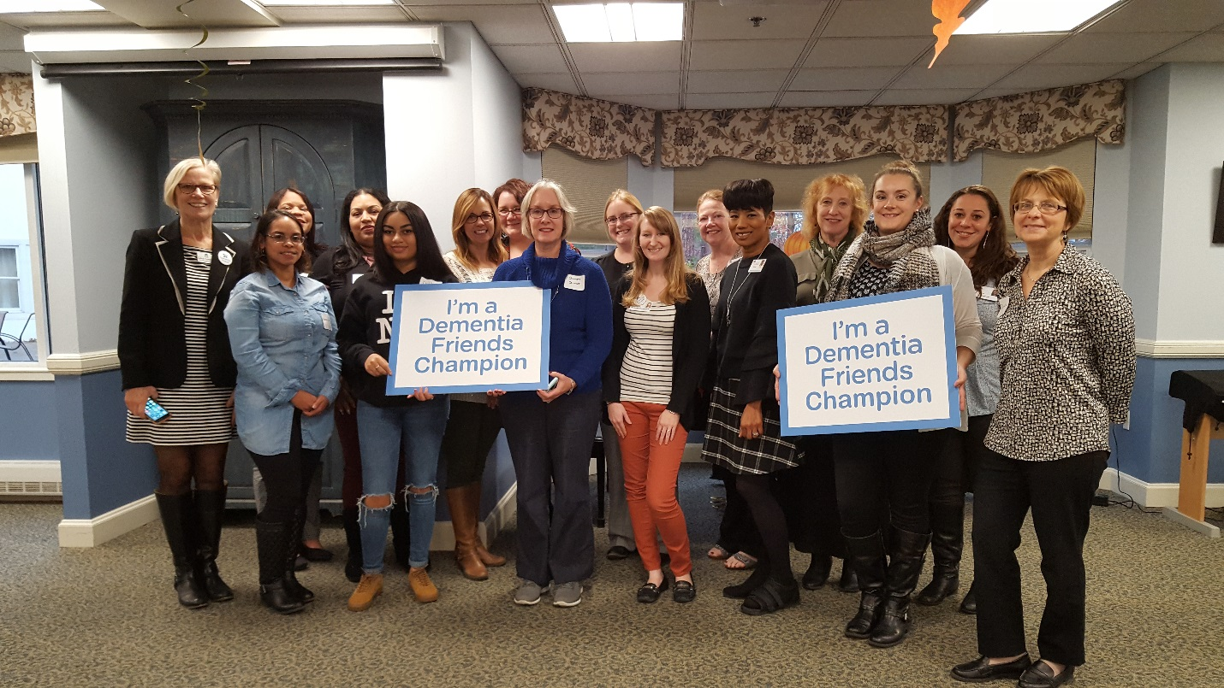
Figure 1Champion training, Loomis Communities, Springfield, led by Beth Soltzberg

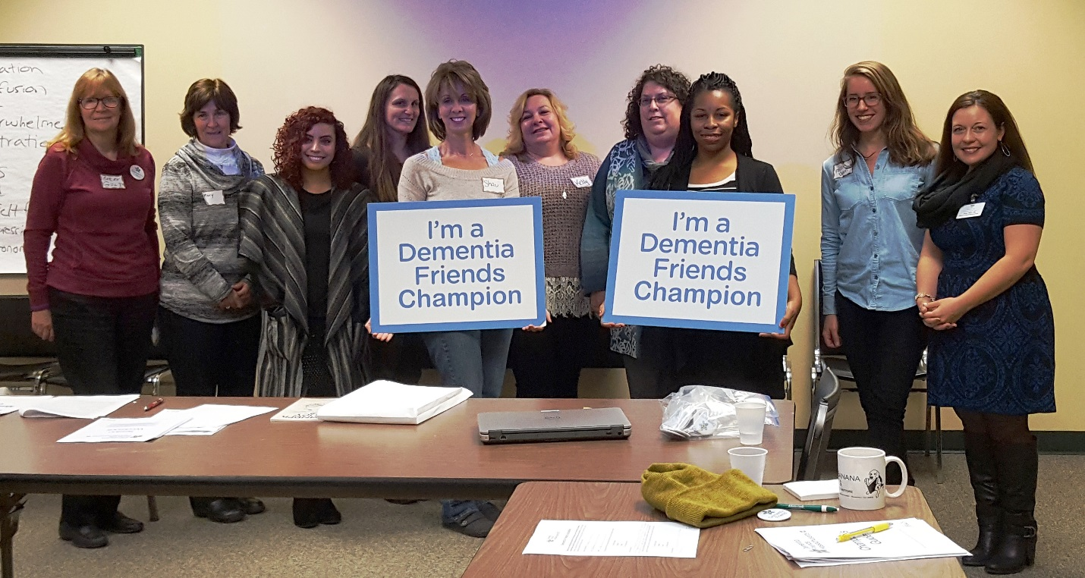
Champion training, Elder Services of Berkshire County, led by Beth Soltzberg

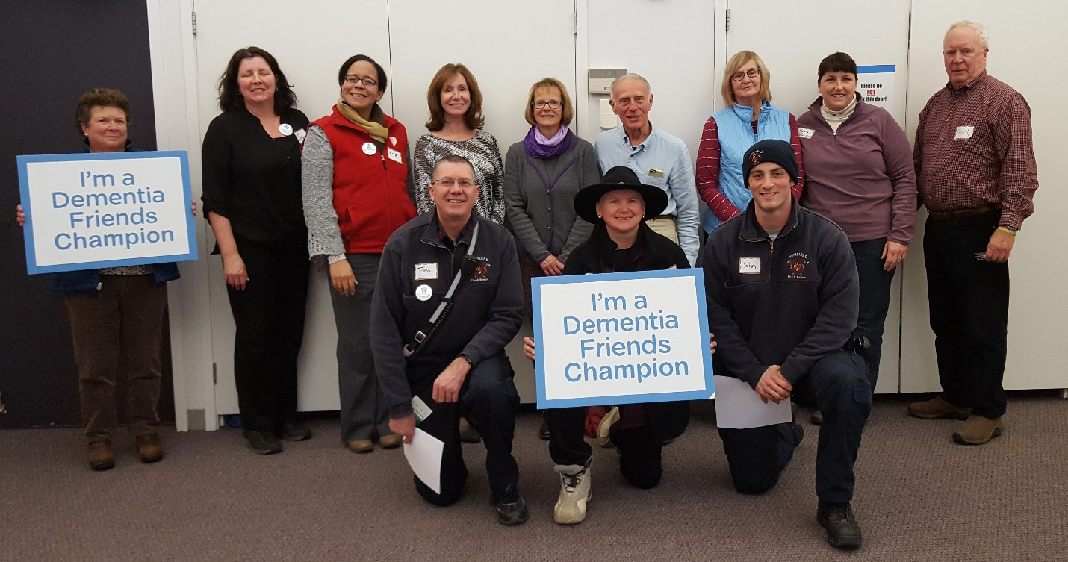
Champion training, Topsfield, led by Beth Soltzberg

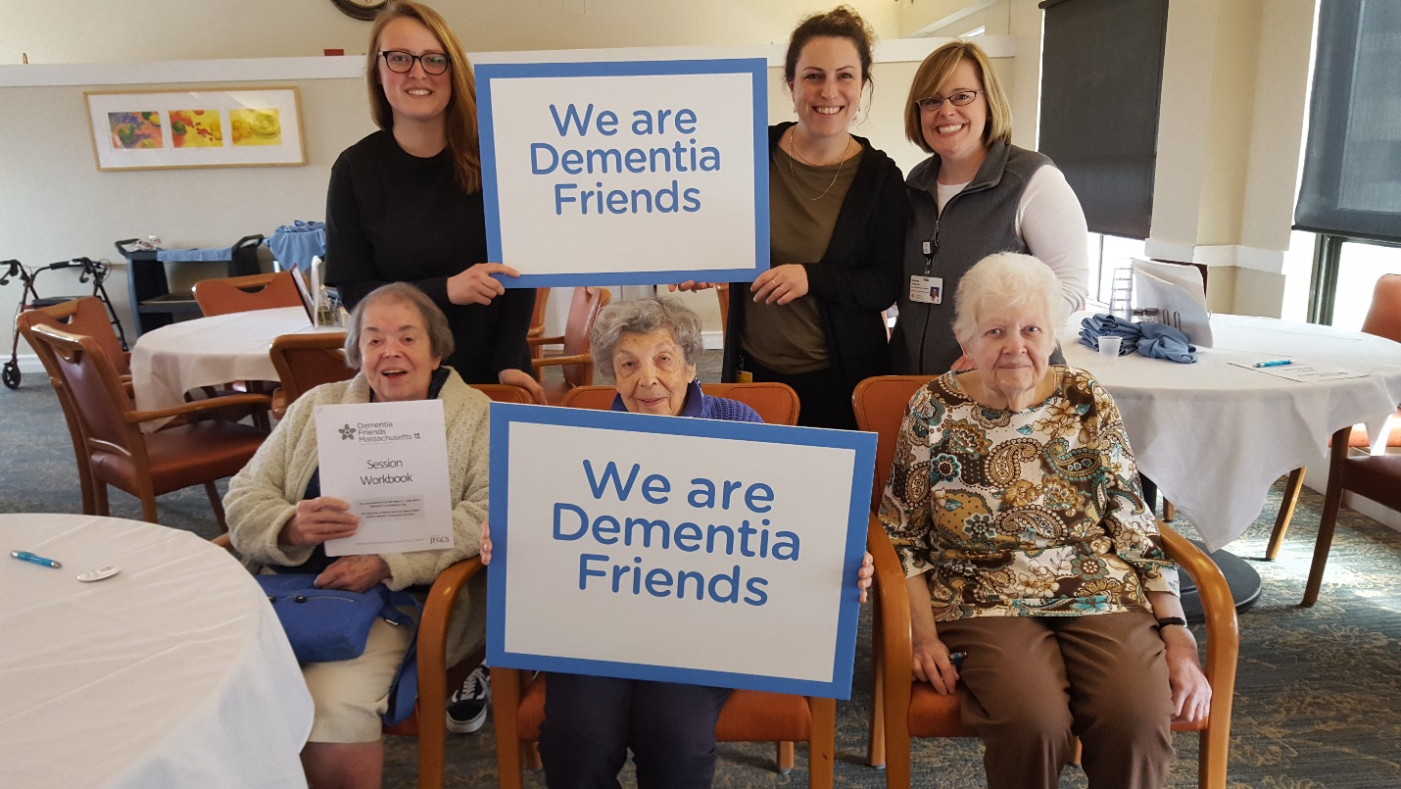
Centre Communities, Brookline, led by Robin Krawczk and Beth Soltzberg

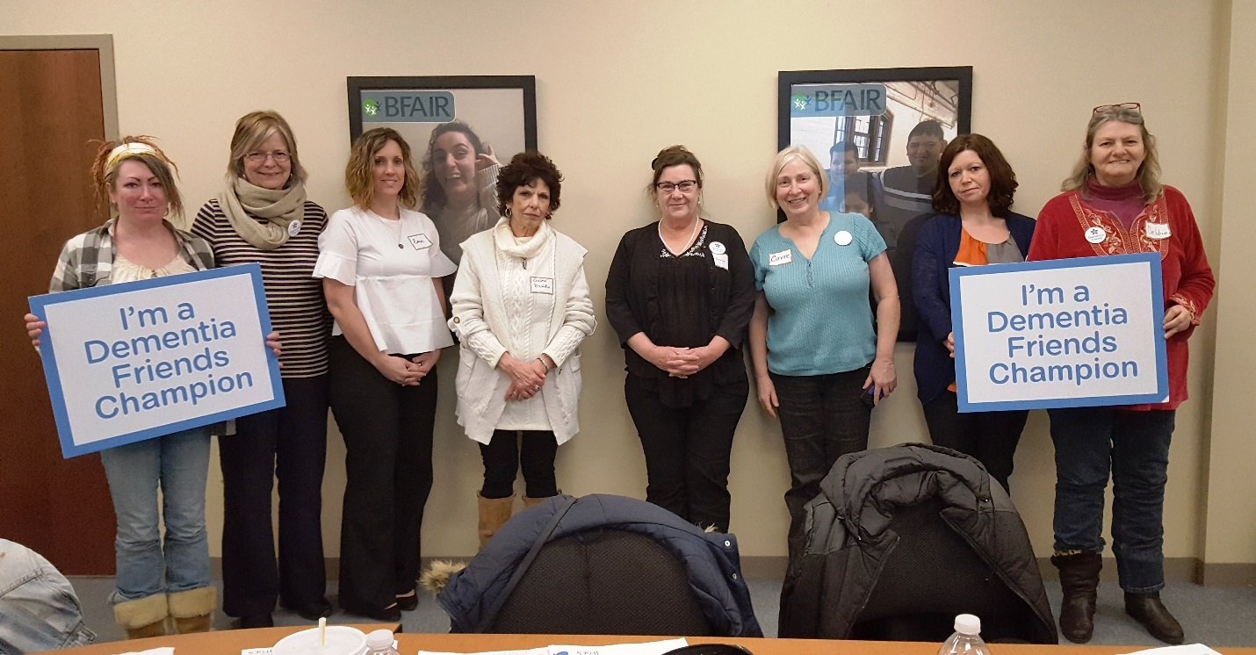
Champion training, BFAIR, North Adams, led by Beth Soltzberg
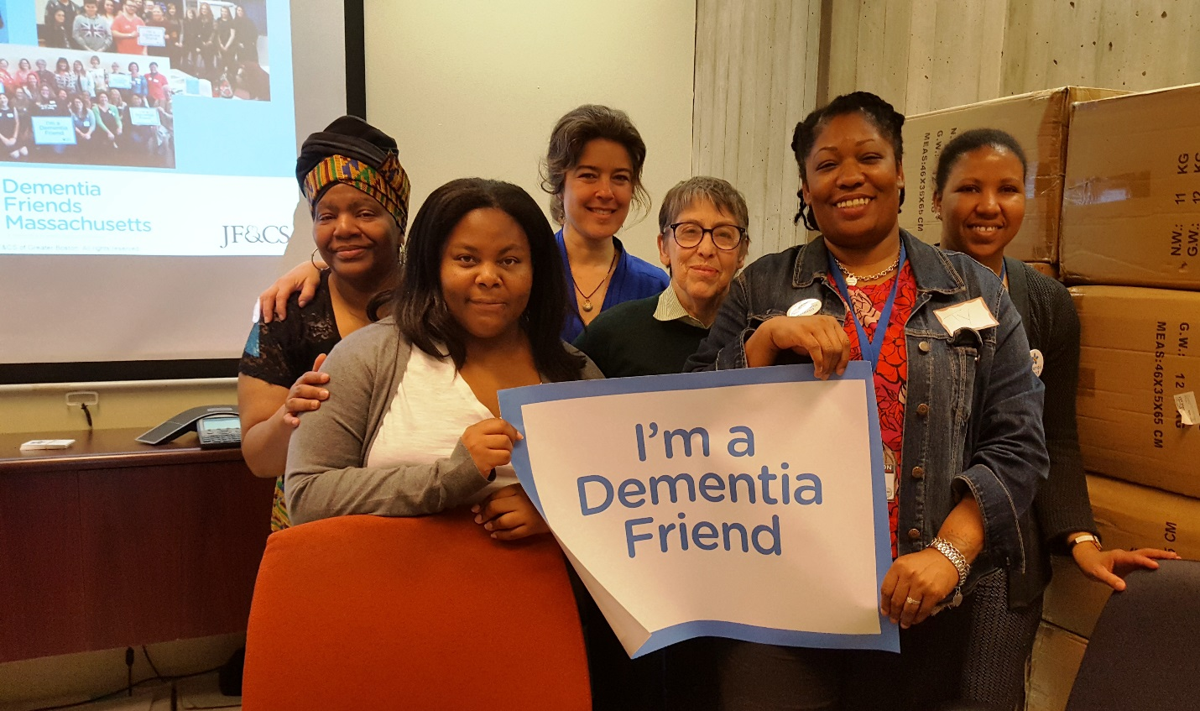
Figure 2Champion Training in collaboration with Boston Alzheimer's Initiative, Boston City Hall, led by Beth Soltzberg

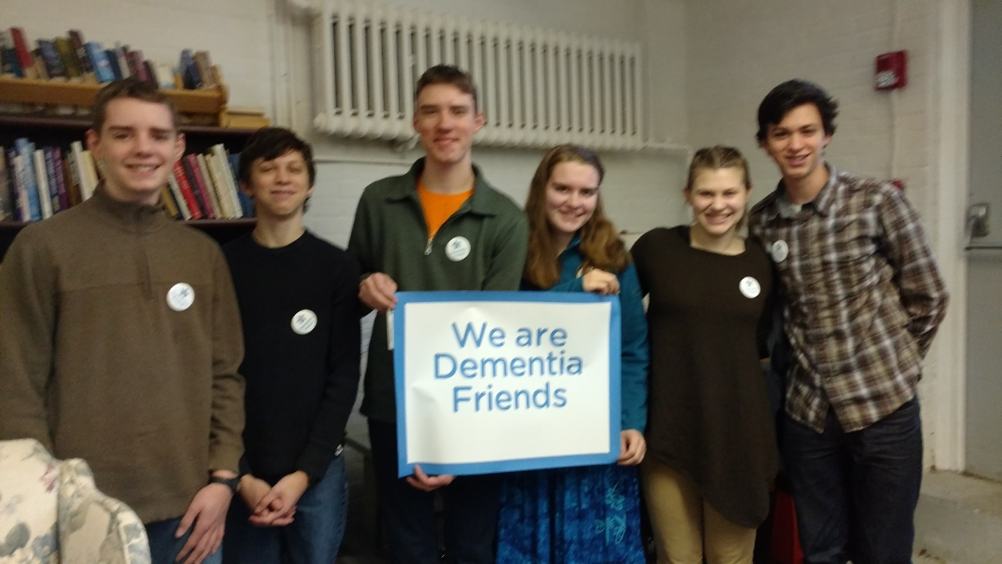
Led by Denise Lawrence; Too blurry to use?? 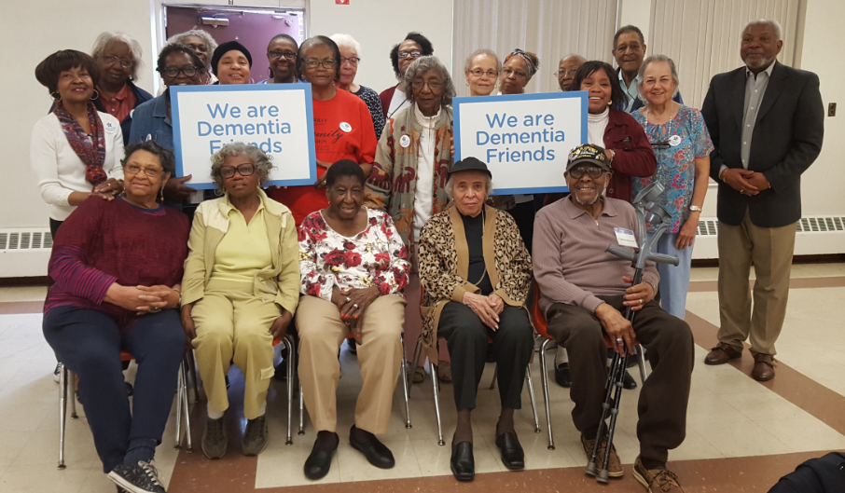
Ellder HealthCare Disparaties Coalition, Roxbury, May2017, led by Beth Soltzberg, with Binta Barry attending from Alz Assoc

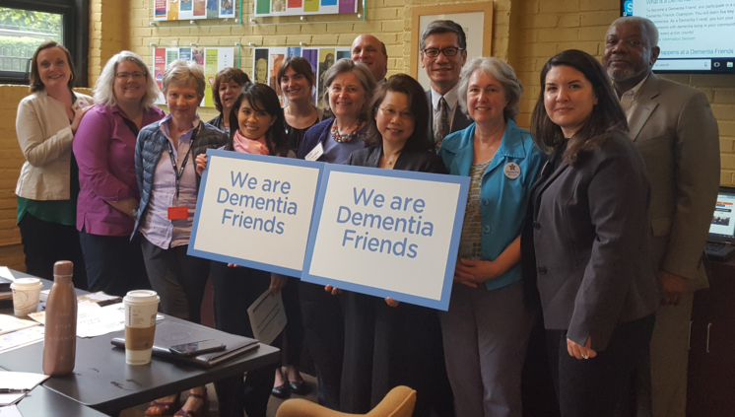
Multicultural Coalition on Aging, led by Beth Soltzberg, 6/6/18

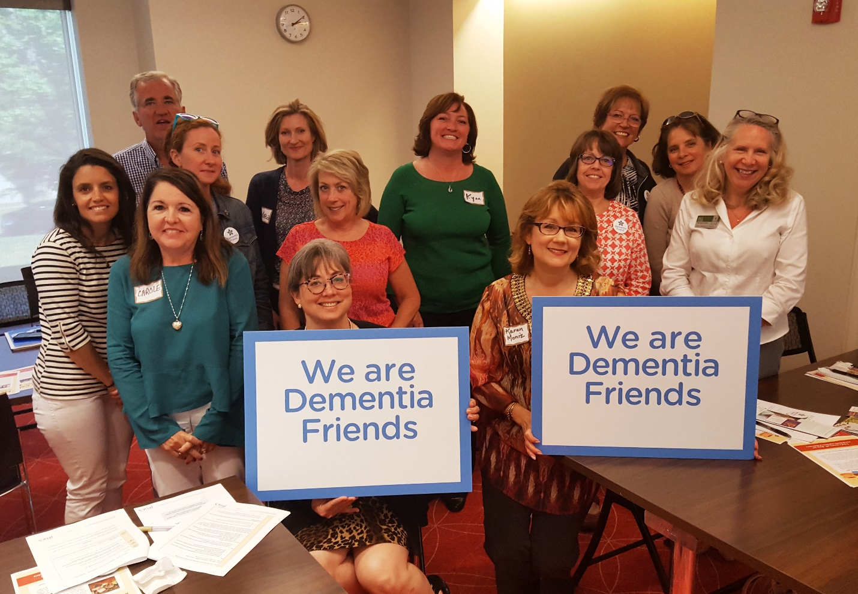
Reading Public Library, 6/11/18, Champion training, led by Beth

